**Exp. 16 Configure a new VM**

**Aim:**

To demonstrate Platform as a Service (PaaS) create and configure a new VM Image in any Public Cloud Service Provider.

**Procedure:**

* Sign in to Azure Portal
* Create a resource group
* Then create a virtual machine
* Allocate storage and ram for it
* Set username and passwords
* Download the RPD file by connecting the VM to the IP address\
* Use that RPD file to access the VM

**Output:**

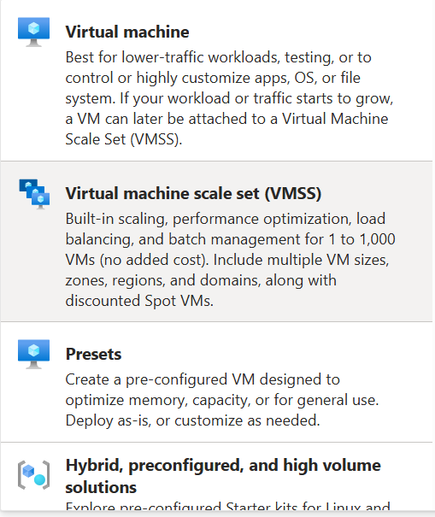

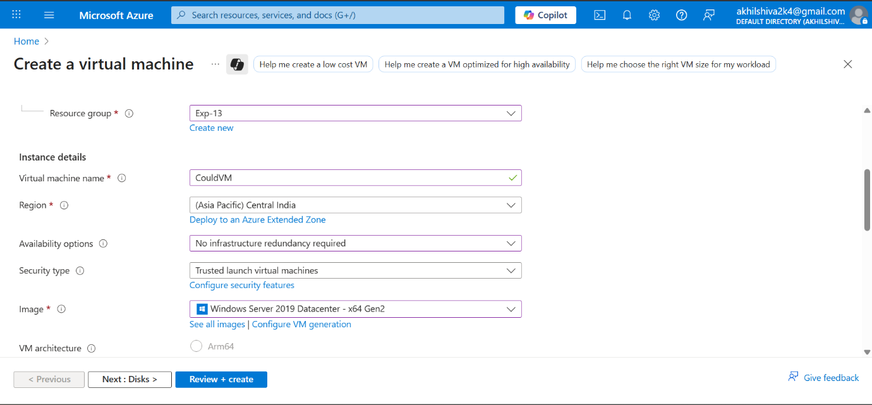

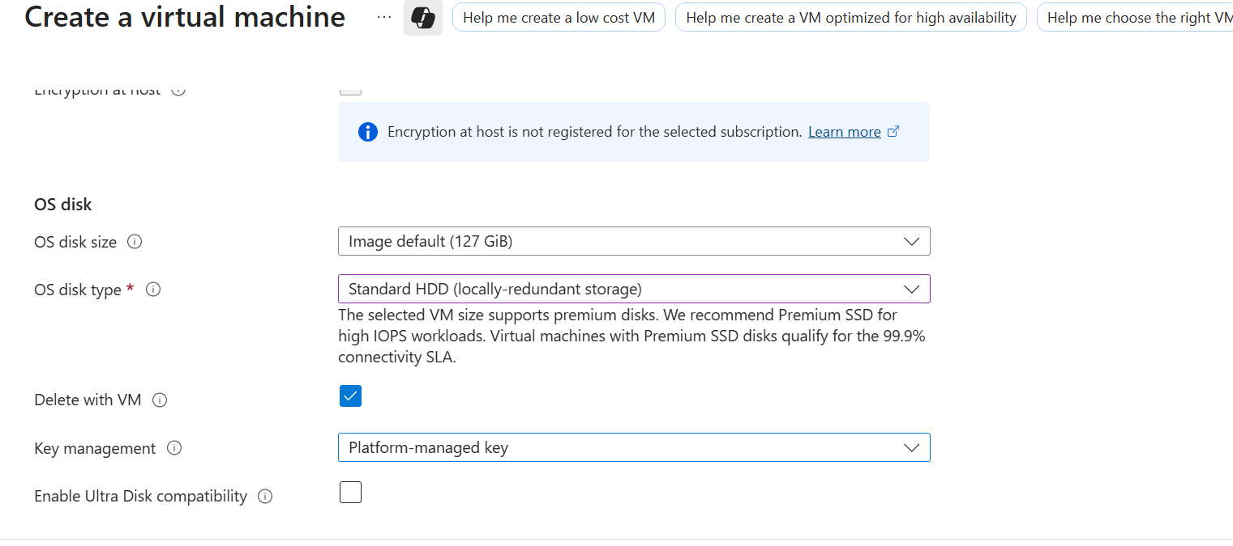

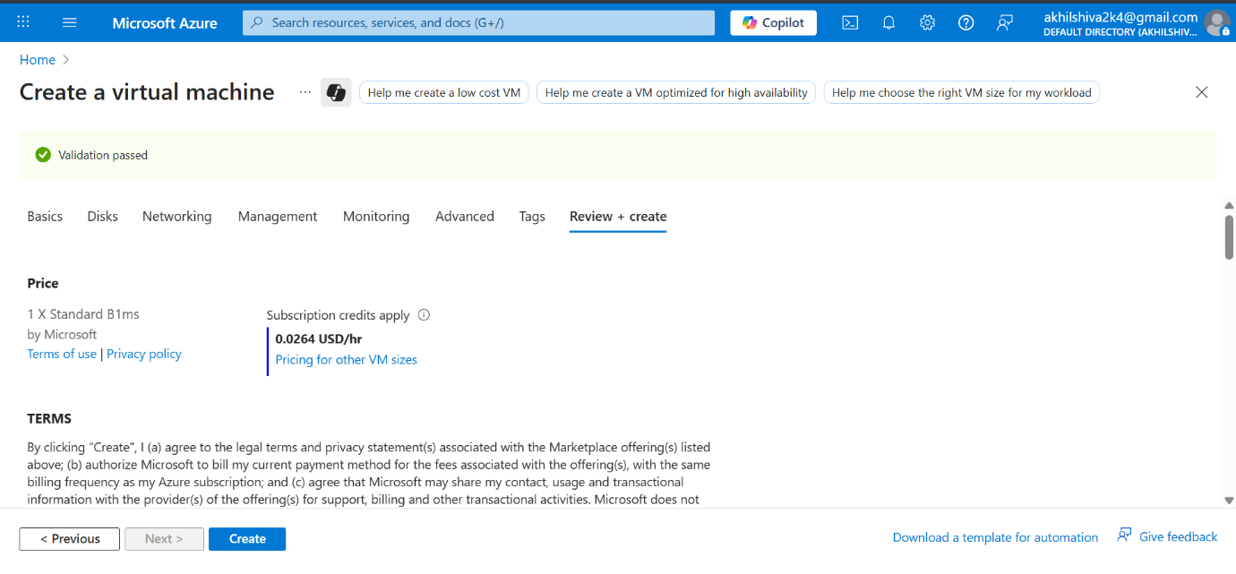

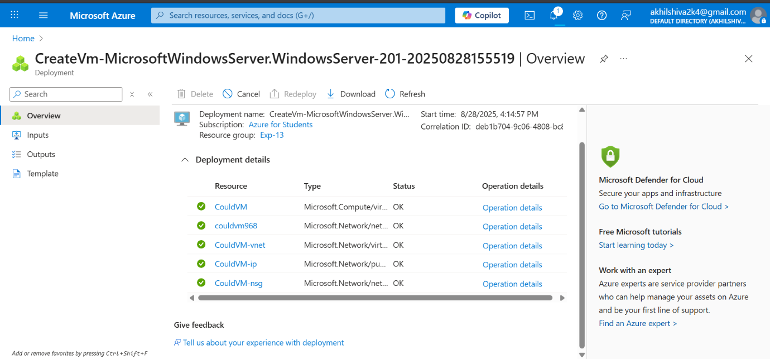

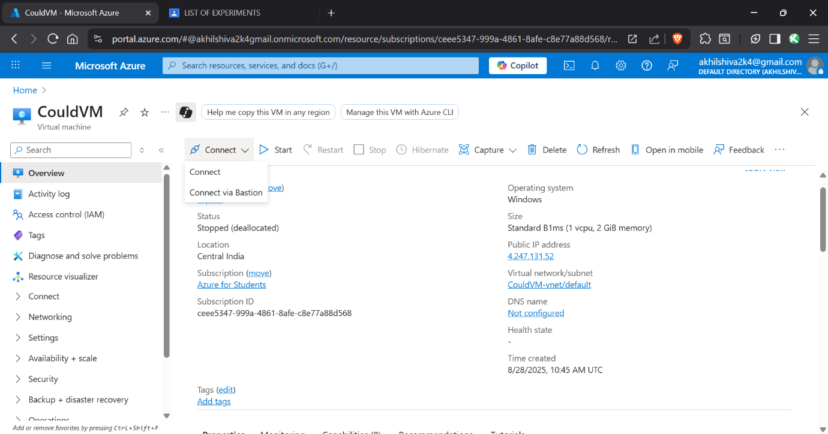

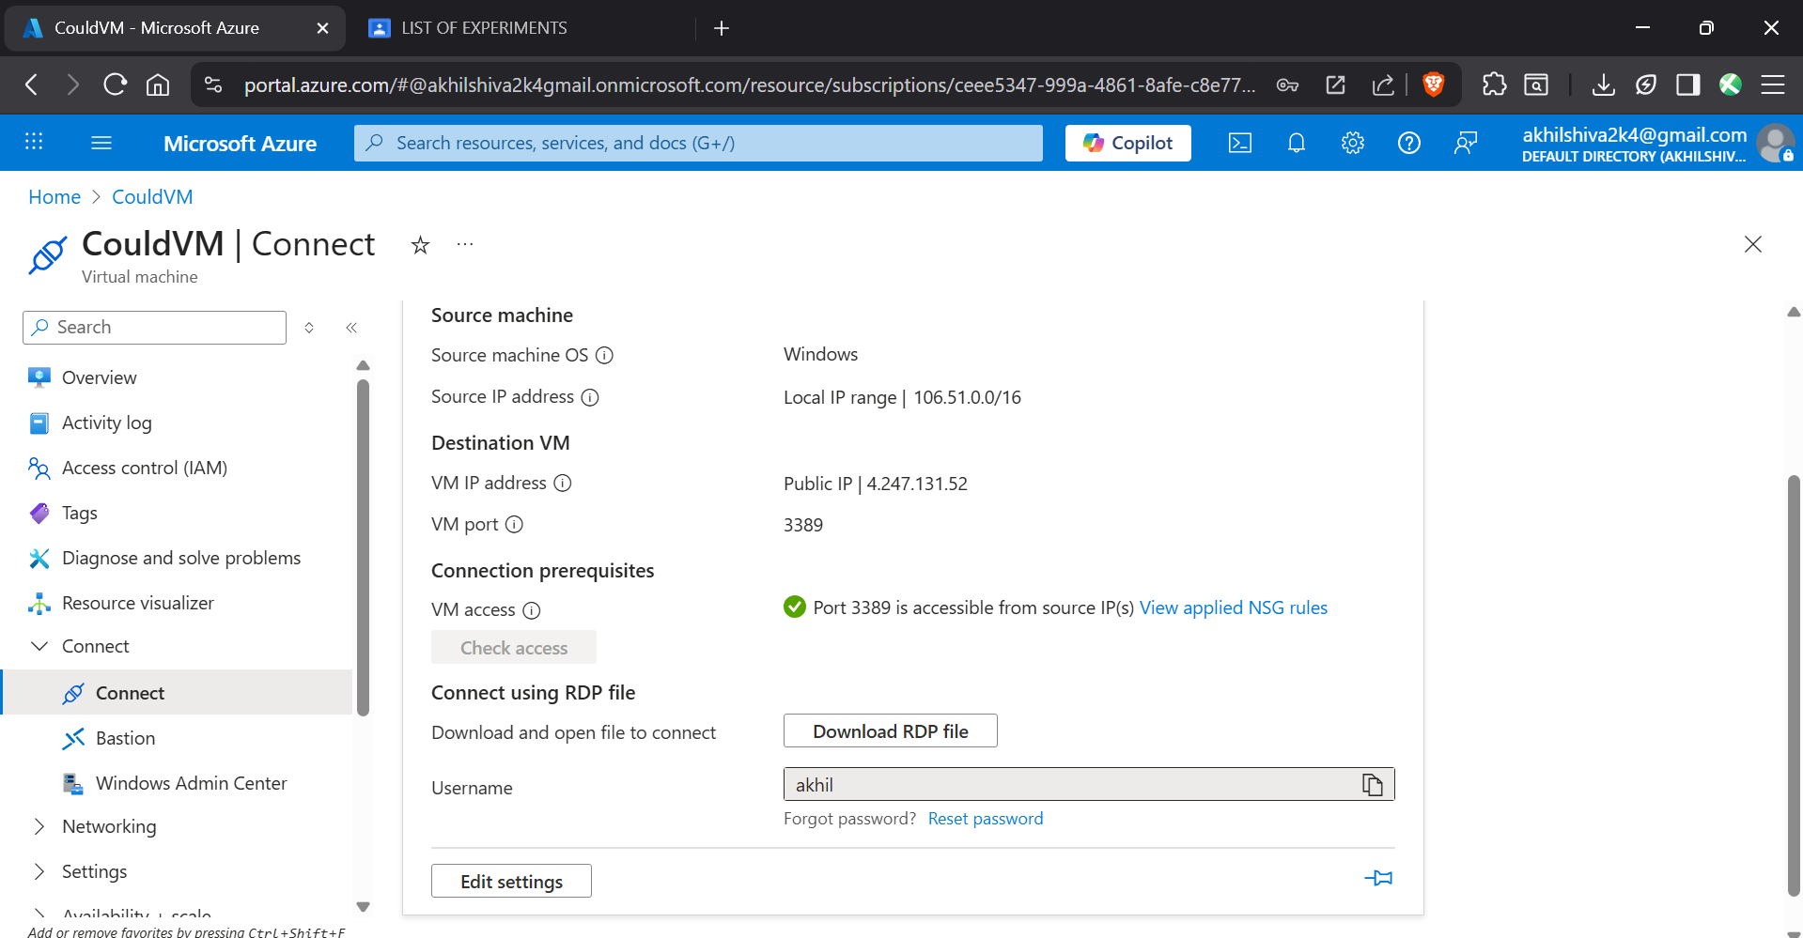

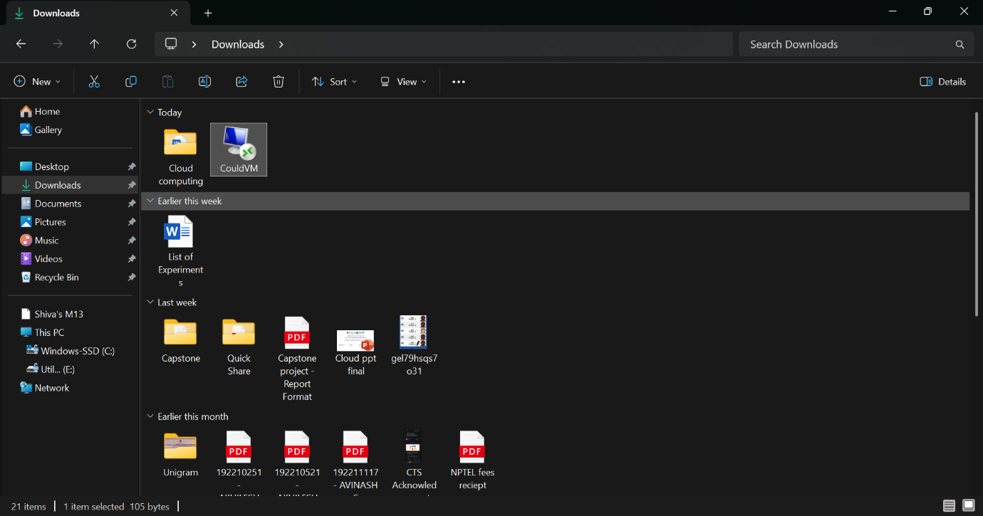

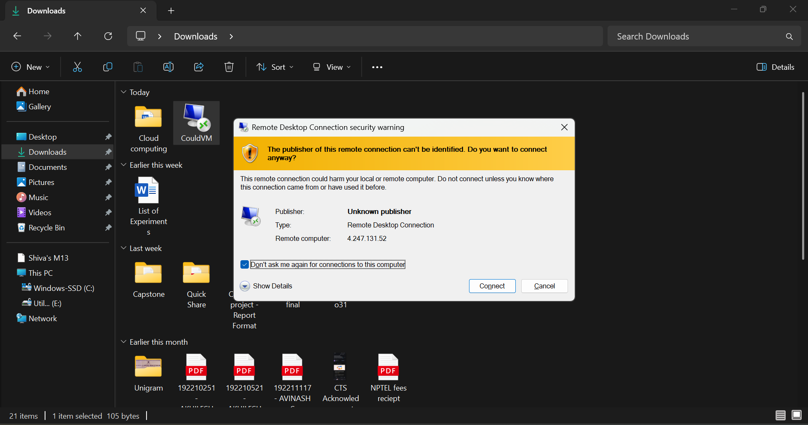

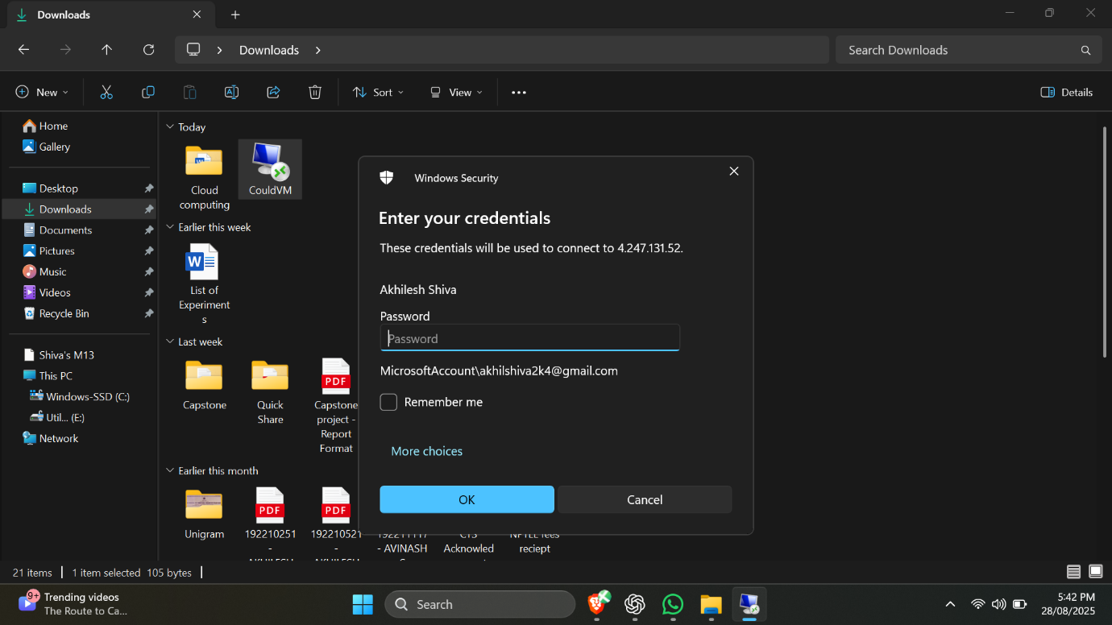

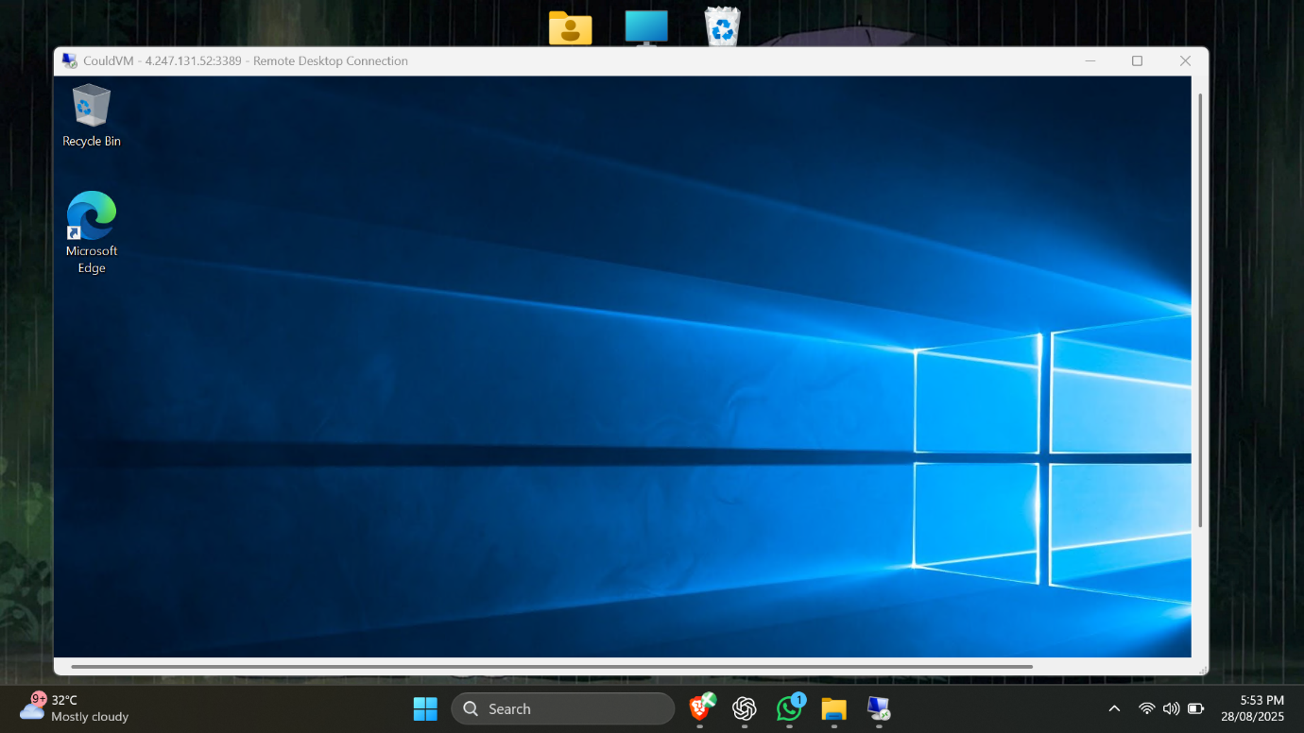

**Result:**

Thus a new VM was configures using Azure